Logging into Your First Meeting

Starting the Meeting
- Before our meeting starts, I will send you an email that contains a link to our online classroom.
- When our meeting is due to begin, click the link provided.
- Once you click the link, Zoom will automatically start the session on your computer.
- Helpful Tip: Bookmark the link. We will use the same link for every meeting.

First Time Using Zoom
- If it is your first time using Zoom, Zoom may ask to install the Zoom Launcher (zoomlauncher.zip) when you click the link. This process can take up to three minutes. As such, for your first meeting, it is a good idea to log in early.
- Accept the download.
- Open the Zoom Launcher and allow the program to run on your computer.
- When you run the program, Zoom will ask you to enter the name you prefer to display in the meeting. Type in your name and be sure the box is checked next to “Remember my name for future meetings.” Then click “Join.”

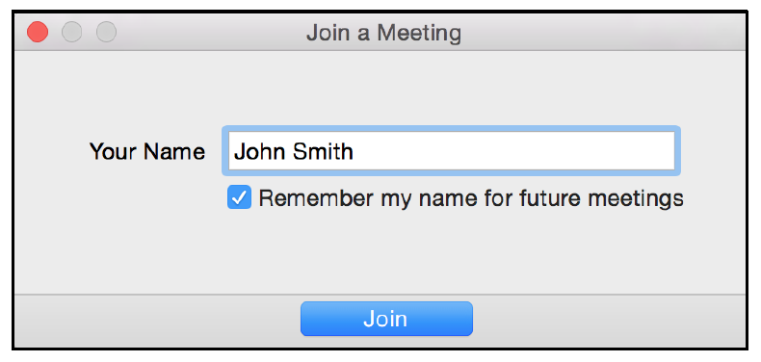
- Zoom will automatically take you to the online classroom where I’ll be waiting.

Turning on Camera/Audio
- Once you arrive in the meeting, neither your video or audio will be on. You will need to turn these on manually.
- Video
  - A pop-up window will appear to start your video. You will see preview of how you look on camera. Below the preview select “Join with Video.”
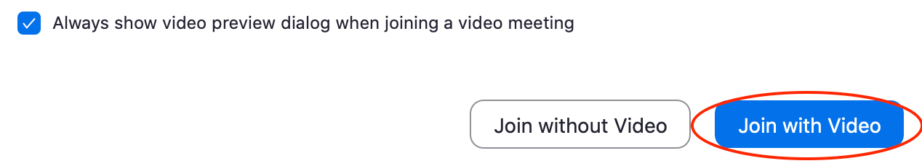
  - You can also turn your video on or off once in the meeting room at the bottom of the screen by clicking “Stop/Start Video.”

- Audio
  - A pop-up window will appear to start your audio. Select “Join Audio by Computer.” Your audio will start broadcasting after clicking this button.

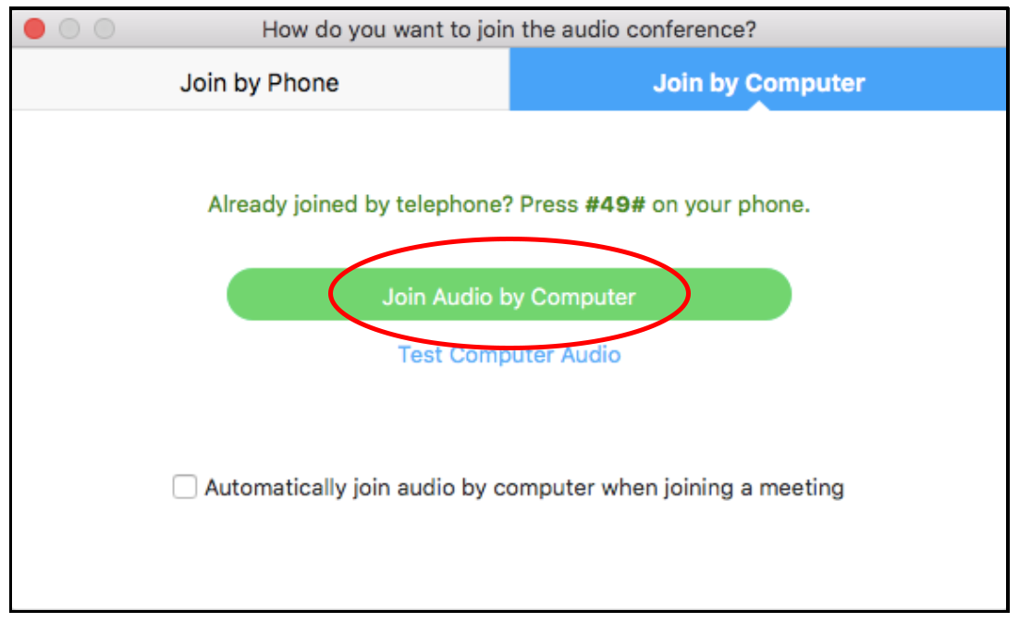

  - Before clicking “Join Audio by Computer,” you can also select the box next to “Automatically join audio” if you want to avoid this step in the future.
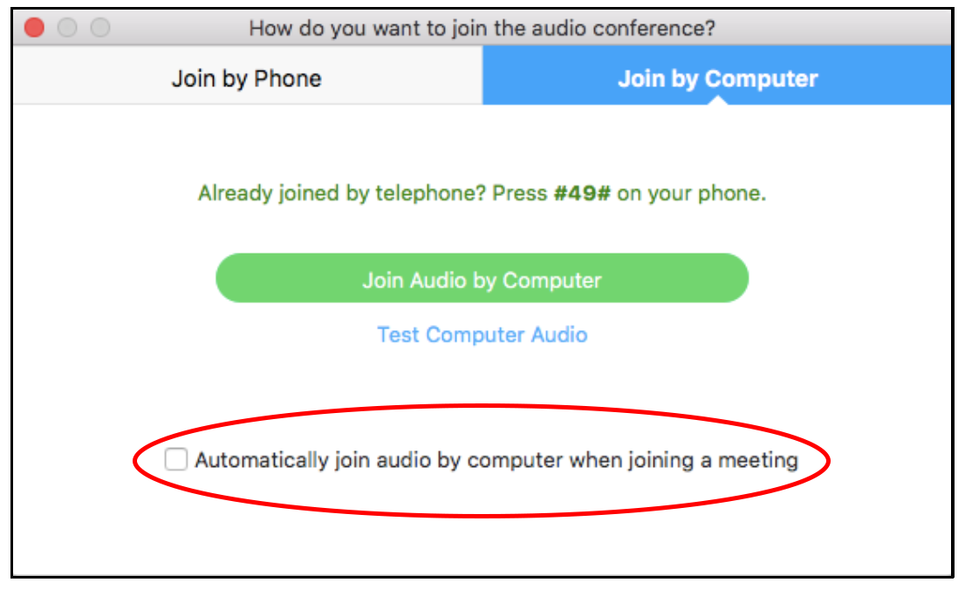

If you experience any issues, contact me by phone at XXX-XXX-XXXX.

